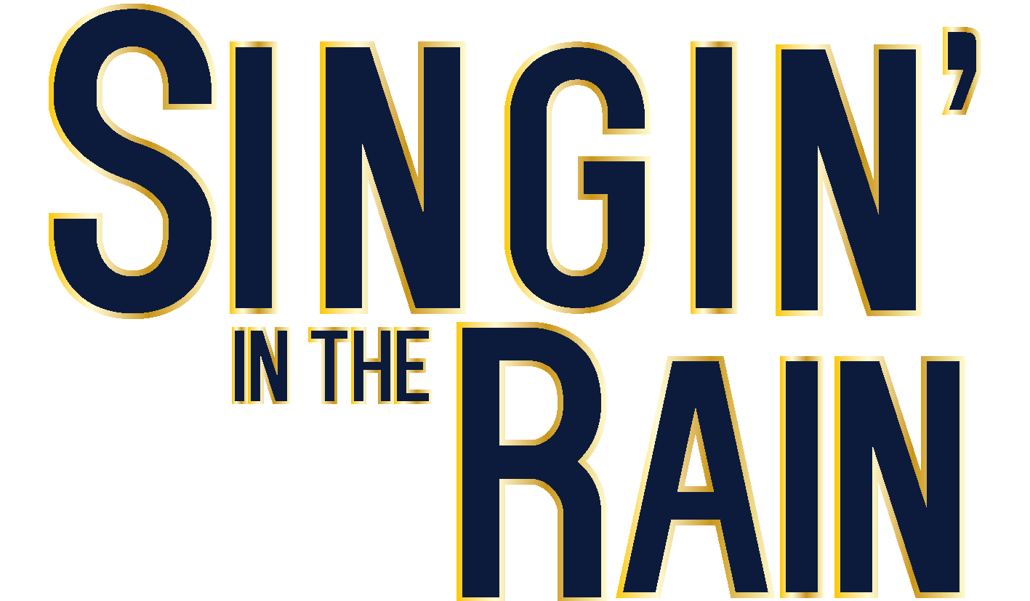
THE DUELLING CAVALIER

LINA: Oh Pierre, you shouldn’t have come. You’re flirting with danger! They will surely find you out!
DON: ‘Tis Cupid himself that called me here and I must come charging to your side.
LINA: But the night is full of our enemies.
DON: Imperious princess of the night. I love you!
LINA: Oh, Pierre!

